Digital Assignment – 1

Data Structures

Submitted by: Hari Krishna Shah

VIT ID: 21BCS0167

Ques 1. Write a program that declares and initializes an array of 10 elements, it is a (1-D) one dimensional integer array named temperature. Use the following temperatures to initialize the array: 78 89 65 90 35 20 88 101 56 99 Then, display the contents of the array on the screen and calculate and display the mean (average) of the temperatures.

Answer:

//Hari Krishna Shah

//VIT ID: 21BCS0167

#include <stdio.h>

int main(){

int temperature[10] = { 78, 89, 65, 90, 35, 20, 88, 101, 56, 99}, sum = 0, mean;

printf("The entered temperature are: ");

for(int i = 0; i<10; i++){

printf("%d ", temperature[i]);

sum += temperature[i];

mean = sum/10;

}

printf(".");

printf("\nThe mean temperature is %d.", mean);

return 0;

}

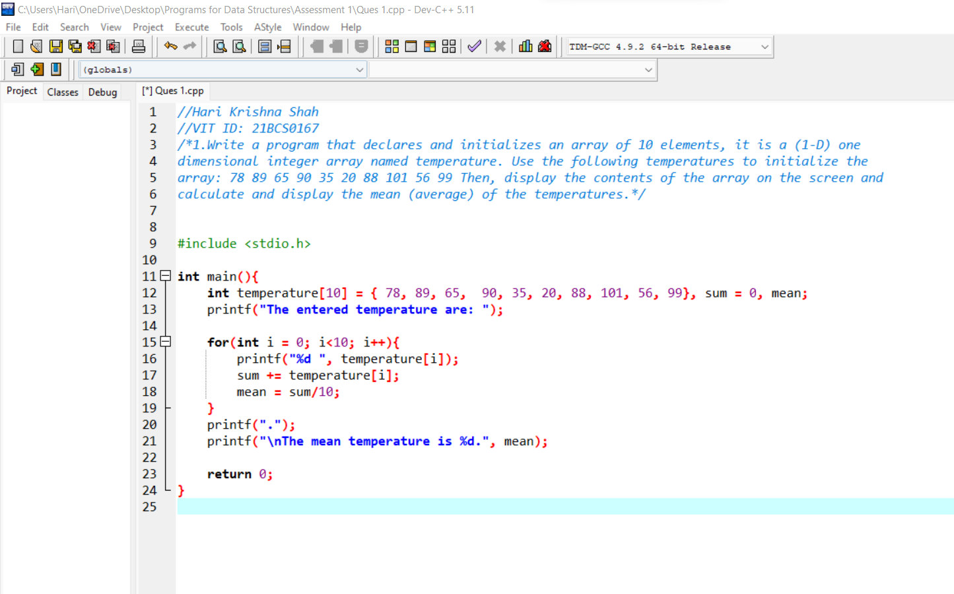

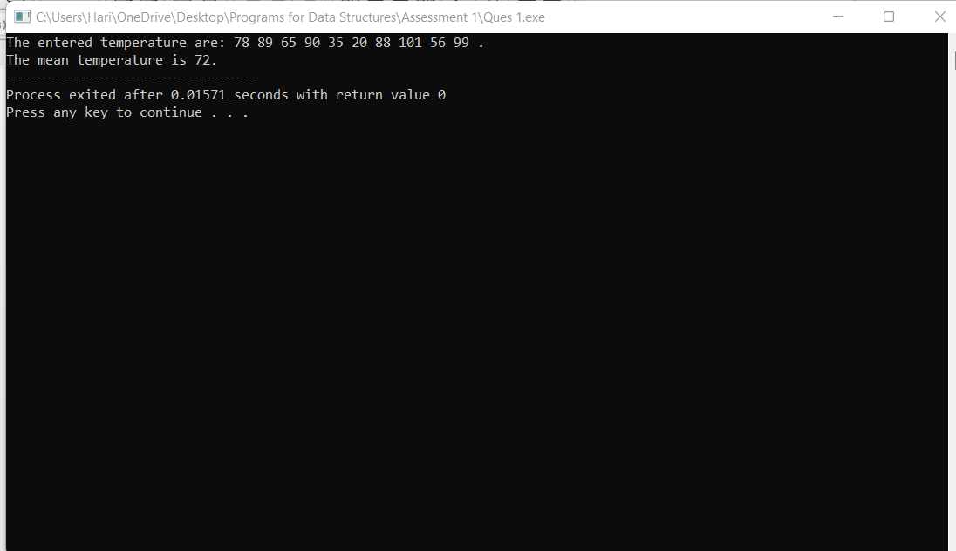

Ques 2. Write a program to store an input list of five numbers in an array named list and display the largest element in the array using a function named get_max. The function get_max will use the array and its size as input parameters and then returns the largest element in the array.

Answer:

//Hari Krishna Shah

//VIT ID: 21BCS0167

#include <stdio.h>

int get_max(int list[5], int size){

int max = list[0];

for(int i = 0; i<size; i++){

if(max<list[i]){

max = list[i];

}

}

return max;

}

int main(){

int list[5], size = 5;

printf("Enter the five numbers to store in the list: ");

for(int i = 0; i<size; i++){

scanf("%d", &list[i]);

}

printf("The largest integer stored in the list is %d.", get_max(list, size));

return 0;

}

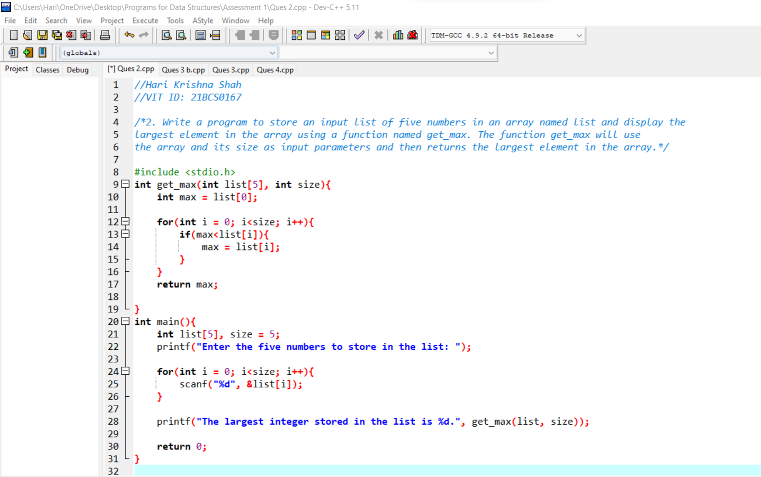

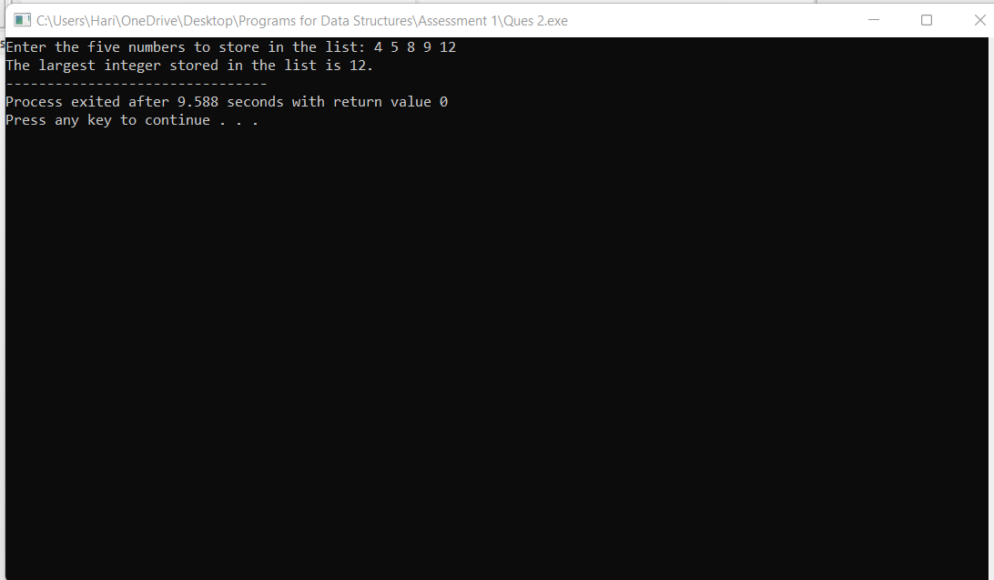

Ques 3. a. Create a structure named company which has name, address, phone and no. Of Employee as member variables. Read name of company, its address, phone and no. Of Employee. Finally display these members’ value.

//Hari Krishna Shah

//VIT ID: 21BCS0167

#include <stdio.h>

int main(){

struct company{

char name[100];

char address[100];

long long int phone;

int no_employees;

};

struct company c1;

printf("Please Enter the details for the company C1 below.");

printf("\nEnter the name of the company: ");

gets(c1.name);

printf("Enter the address of the company: ");

gets(c1.address);

printf("Enter the phone number of the company: ");

scanf("%lld", &c1.phone);

printf("Enter the number of employess in the company: ");

scanf("%d", &c1.no_employees);

printf("\nThe details of the company c1 are given below:");

printf("\nThe name of the company is %s.", c1.name);

printf("\nThe address of the company is %s.", c1.address);

printf("\nThe phone number of the company is %lld.", c1.phone);

printf("\nThe number of employess in the company is %d.", c1.no_employees);

return 0;

}

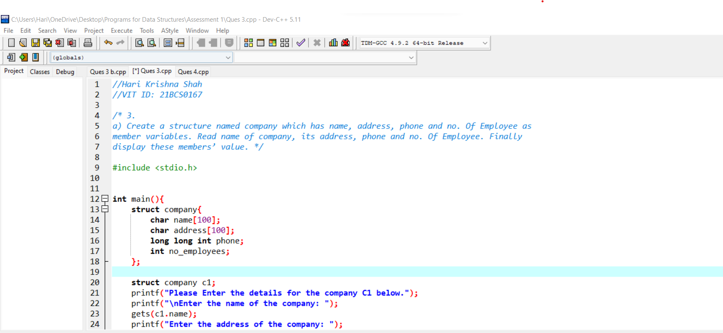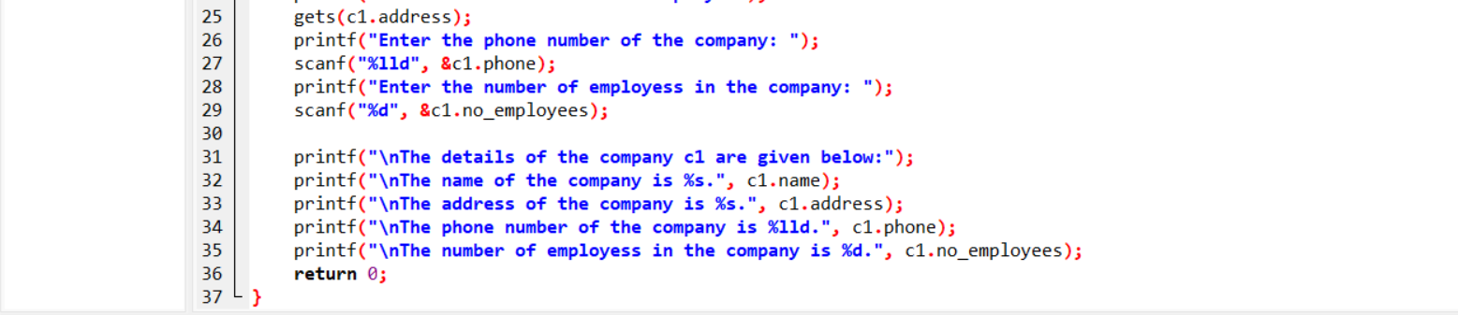

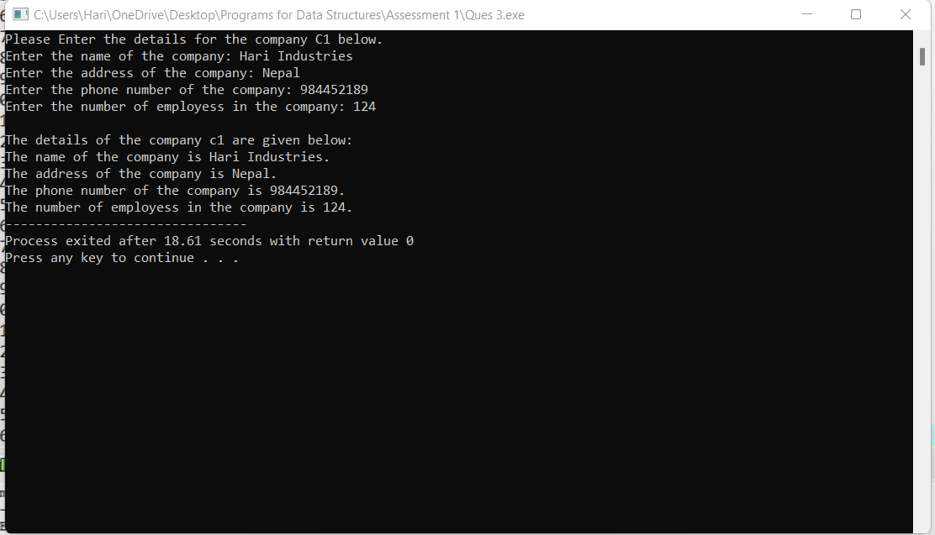

Ques 3. b. Create a structure named company which has name, address, phone and no. Of Employee as member variables. Pass the structures defined in Question into a function and read the structure member and display the values.

Answer:

//Hari Krishna Shah

//VIT ID: 21BCS0167

#include <stdio.h>

struct company{

char name[100];

char address[100];

long long int phone;

int no_employees;

};

void readAndwrite(struct company *c){

printf("Please Enter the details for the company C1 below.");

printf("\nEnter the name of the company: ");

gets(c->name);

printf("Enter the address of the company: ");

gets(c->address);

printf("Enter the phone number of the company: ");

scanf("%lld", &c->phone);

printf("Enter the number of employess in the company: ");

scanf("%d", &c->no_employees);

printf("\nThe details of the company c1 is given below.");

printf("\nThe name of the company is %s.", c->name);

printf("\nThe address of the company is %s.", c->address);

printf("\nThe phone number of the company is %lld.", c->phone);

printf("\nThe number of employess in the company is %d.", c->no_employees);

}

int main(){

struct company c1;

readAndwrite(&c1);

return 0;

}

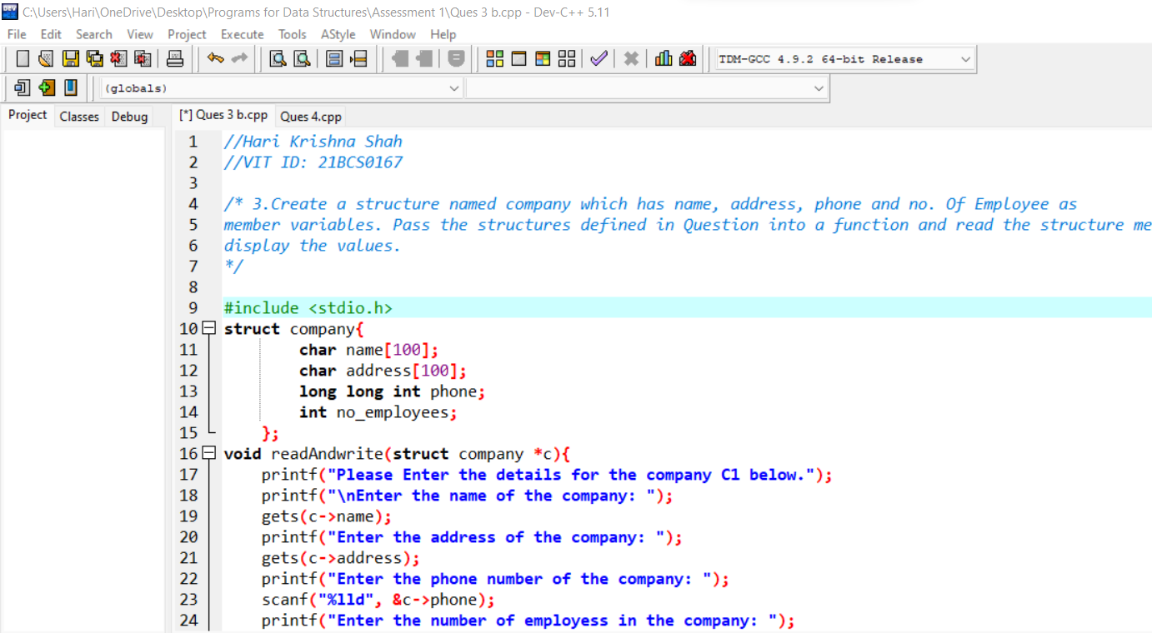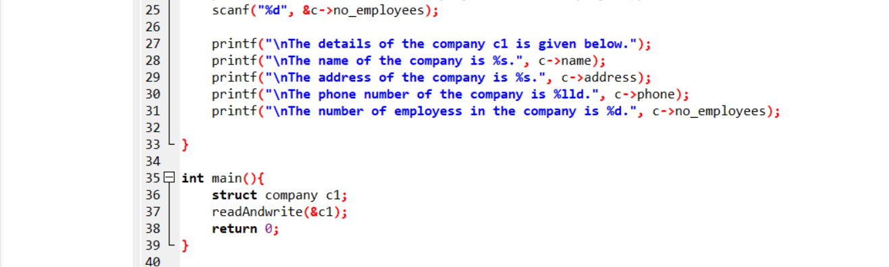

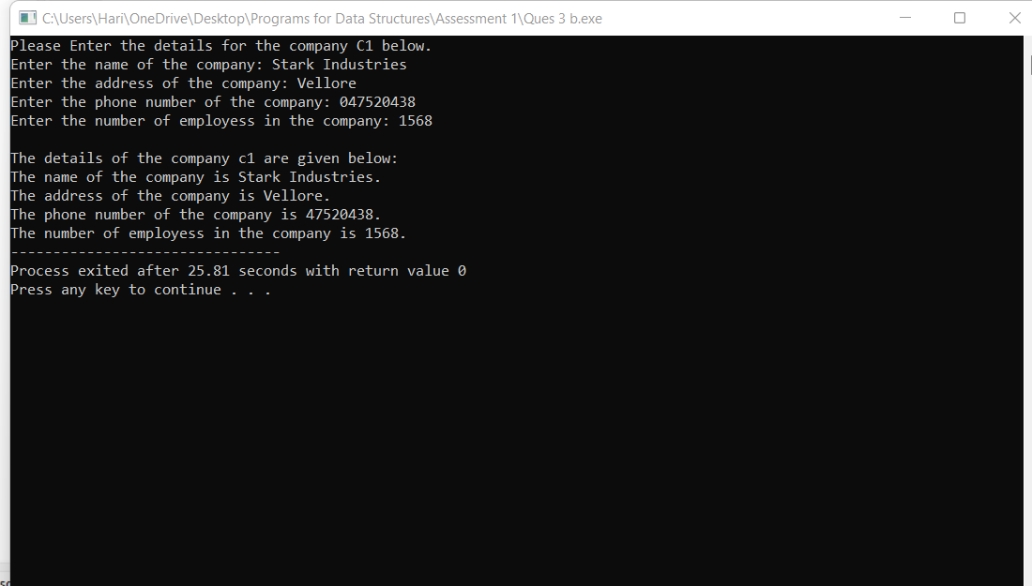

Ques 4. Define a structure “complex” to read two complex numbers and perform addition, subtraction of these two complex numbers and display the result (implement using pointers with structures).

Answer.

//Hari Krishna Shah

//VIT ID: 21BCS0167

#include <stdio.h>

#include <math.h>

int main(){

struct complex

{

float real;

float imaginary;

};

struct complex c1, c2;

printf("Enter the real part of the first number: ");

scanf("%f", &c1.real);

printf("Enter the imaginary part of the first number: ");

scanf("%f", &c1.imaginary);

printf("The first complex number is %.2f + %.2fi.", c1.real, c1.imaginary);

printf("\n\nEnter the real part of the second number: ");

scanf("%f", &c2.real);

printf("Enter the imaginary part of the second number: ");

scanf("%f", &c2.imaginary);

printf("The second complex number is %.2f + %.2fi.", c2.real, c2.imaginary);

printf("\n\nThe sum of the two complex number is given by: \nSum = %.2f + %.2fi", c1.real + c2.real, c1.imaginary + c2. imaginary);

return 0;

}

